**Code**

1. public int test(int a, int b, int c){
2. int s;
3. boolean IsTriangle;
4. if ((a<b+c)&&(b<a+c)&&(c<a+b)){
5. IsTriangle = true;
6. }
7. else{
8. IsTriangle = false;
9. }
10. if (IsTriangle){
11. if((a==b)||(b==c)){
12. s = 1;
13. }
14. else if((a!=b)&&(a!=c)&&(b!=c)){
15. s = 3;
16. }
17. else{
18. s = 2;
19. }
20. }
21. else{
22. s = 4;
23. }
24. return s;
25. }

**Graph**

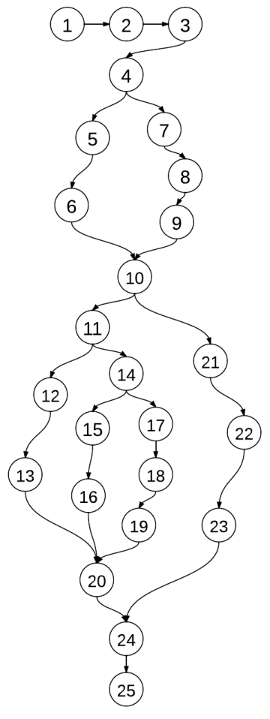 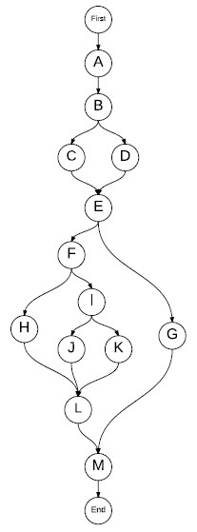

Program Graph DD-path Graph

**C1: Cover Every DD-Path**

**Model**

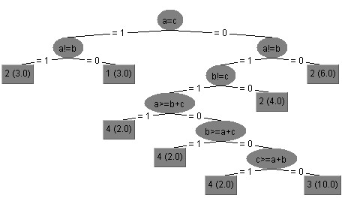

|  |  |  |  |  |  |
| --- | --- | --- | --- | --- | --- |
|  | | DD-Path Coverage | Input | Output(code) | Output(model) |
| 1 | P1 | First, A, B, C, E, F, H, L, M, End | 5, 5, 5 | Equilateral | Equilateral |
| P2 | First, A, B, C, E, F, I, J, L, M, End | 9, 7, 13 | Scalene | Scalene |
| P3 | First, A, B, C, E, F, I, k, L, M, End | 3, 5, 3 | Isosceles | Isosceles |
| P4 | First, A, B, D, E, G, M, End | 3, 4, 7 | Not a Triangle | Not a Triangle |
| 1 | P1 | First, A, B, C, E, F, H, L, M, End | 3, 4, 4 | Equilateral | Isosceles |
| P2 | First, A, B, C, E, F, I, J, L, M, End |  |  |  |
| P3 | First, A, B, C, E, F, I, k, L, M, End |  |  |  |
| P4 | First, A, B, D, E, G, M, End |  |  |  |